# **Transformer Design**

In order to determine the turn ratio of the transformer, we can look at the push pull converter voltage equation.

$$V_{out}={2*V}_{in}*D*\frac{N_{2}}{N_{1}}$$

In the design requirements, we know that input voltage varies between the 24V and 48V. Also, push pull converter requires duty cycle which is smaller than the 0.5.

If we put a range for duty cycle such as 0.2 < D <0.4, we can find the necessary turn ratio

$$15=2*48*0.2*\frac{N_{2}}{N_{1}} =>\frac{N_{2}}{N_{1}}=0.78$$

To make the number of turn as integer, we can select the $\frac{N_{2}}{N_{1}}=0.75=\frac{3}{4}=\frac{6}{8}$

Minimum number of turns can be determined as the flux density in the core cannot reach the saturation. So, minimum number of turns can be calculated as following formula.

$$\frac{V_{input-max}*D_{maxi}*\frac{1}{f_{s}}}{{2*B}_{sat}*A_{e}}=N_{1}$$

Then, we can use the effective area of the core. Our first core choise is the TDK Electronics B66335G0000X187 magnetic core. Its effective cross-sectional area is 354 mm^2 .

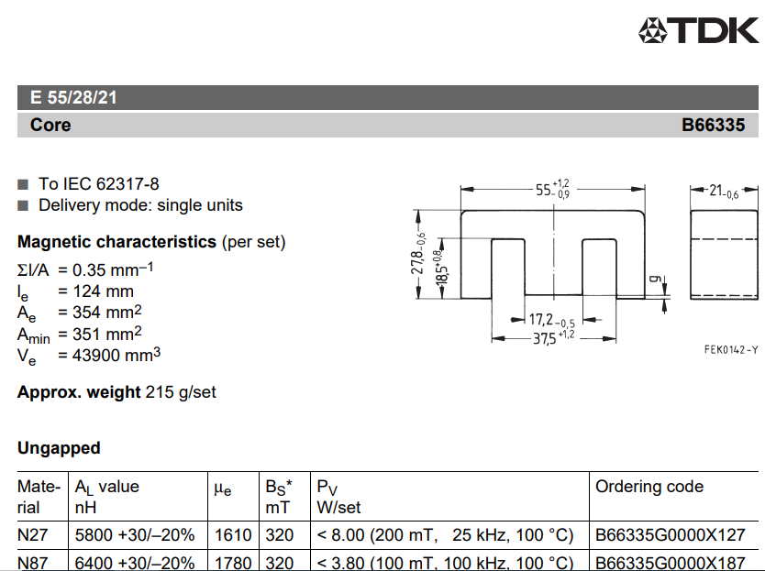

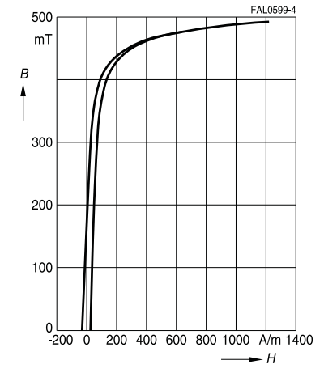

Maximum flux density varies depends on the material of the core. For a safety, we can select as maximum 0.2 T.

$$N_{1-min}=\frac{48*0.4*\frac{1}{100k}}{2*0.2*354x{10}^{-6}}=1.356$$

So, number of turns 6 and 8 is sufficient.

In the simulation, maximum current is 2.2 A for input, 3.3 A for the output. Also, our core has more window area. So, we decided to use directly a litz cable which has 0.3 mm^2 area. Then, when we calculate the fill factor, we obtained the following calculation

$$Fill Factor=\frac{\left(8+6\right)*0.3}{\left(10.15*18.5\right)*2}=\%12$$